 | SIMATS ENGINEERING  Department of Computer Science and Engineering  CSA15 Cloud Computing and Big Data Analytics  CO2 AT2 - VM Configuration and Security Evidence Workbook  Guided practical workbook for Azure VM, local VM, Docker container, security checks, recovery evidence and GitHub submission
Assessment Metadata
Course Code | CSA15
Course Title | Cloud Computing and Big Data Analytics
Assessment | CO2 AT2 - VM Configuration and Security Evidence
Submission Type | Individual digital workbook based on the same capstone title used in CO1 and CO2 AT1
Faculty | Dr C. Rajesh Babu
Employee ID | SSETSCS415
Submission Mode | Completed workbook, evidence screenshots and GitHub repository link through Google Classroom
How This Workbook Works
- Use the same capstone title carried from CO1 and CO2 AT1.
- Read each procedure block, perform the action, verify the checkpoint and then fill the response table.
- Use Azure first when account activation is available. Use the local VM path when Azure is blocked. Use Docker for container comparison. Use simulation only when practical deployment is blocked.
- Screenshots must show the student's actual configuration or verified simulation work. Hide credentials, keys, tokens and sensitive account details.
- Upload the completed workbook and evidence to GitHub, then submit the GitHub repository link through Google Classroom.
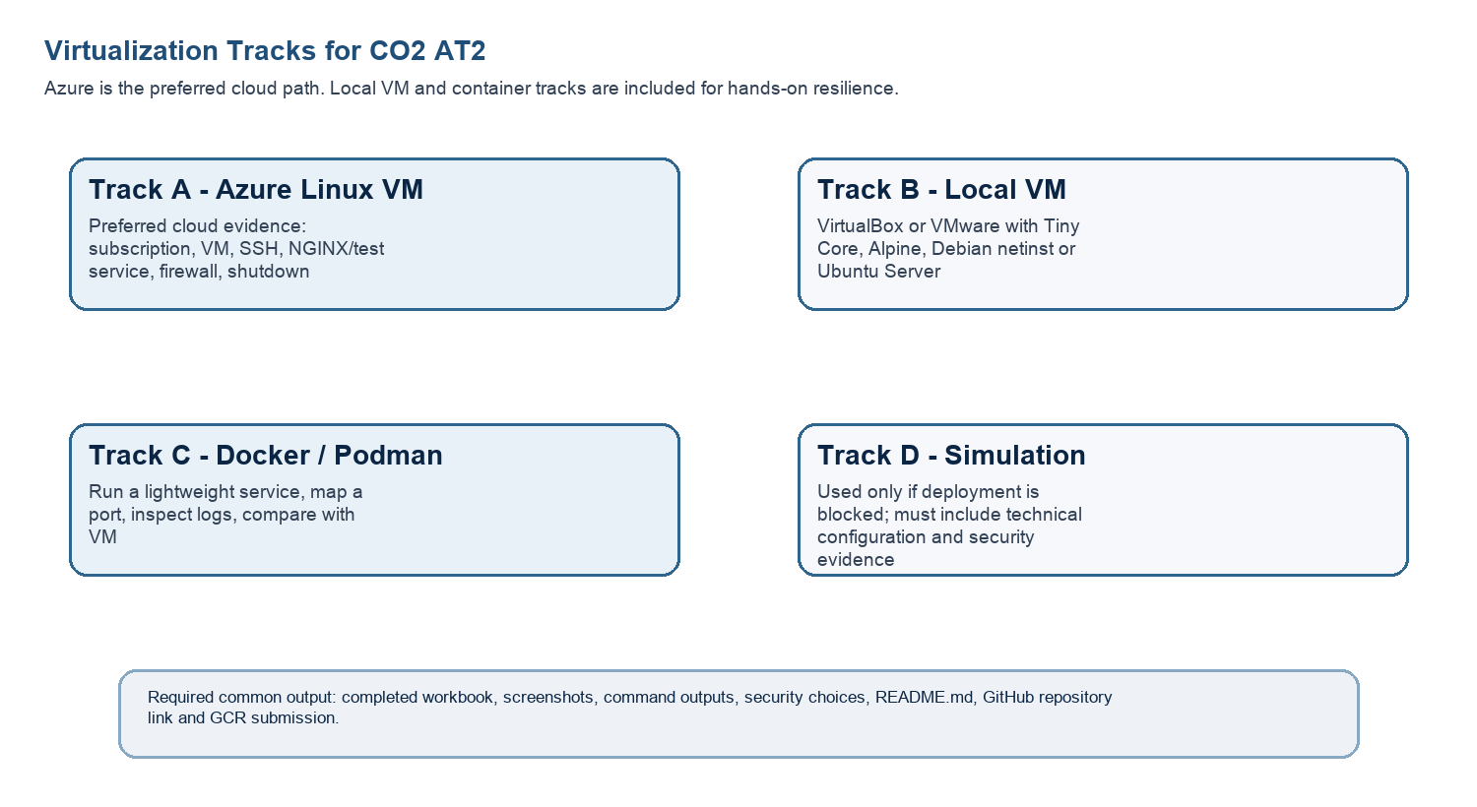
Technical Orientation
The practical work is not limited to clicking through screens. Each checkpoint requires observation: what appeared on screen, why it appeared, what it proves and how it connects to the capstone infrastructure plan.
Part 1: Student and Capstone Baseline
Student Name | Sujith Reddy
Register Number | 192525422
Class / Slot | Slot B
Capstone Title | SafeWalk – Cloud Route Intelligence Using Crowd Reports and Risk Heatmaps
CO2 AT1 Recommended VM Size | vCPU: ____ RAM: ____ Disk: ____
Selected Practical Track | Azure VM (primary), Docker (comparison)
GitHub Repository Link | https://github.com/192525422simats-lab/cloude-computing-
Google Classroom Submission Date | 30-07-26
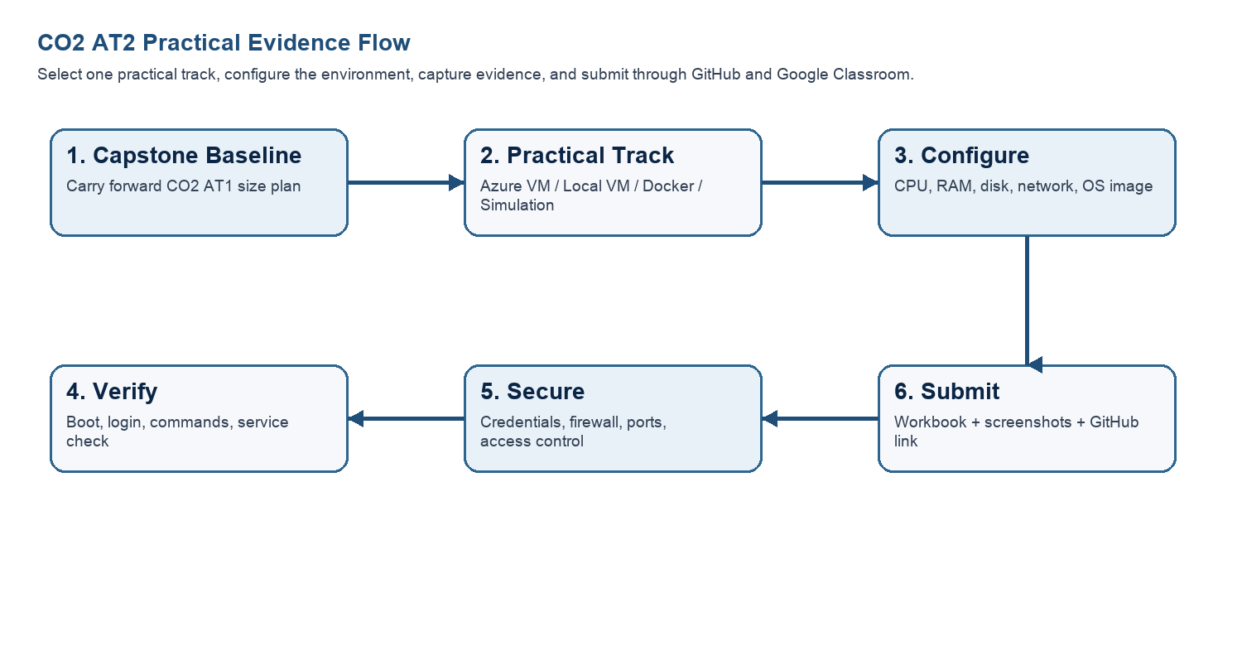
Capstone Infrastructure Element | Carry-Forward from CO2 AT1
Workload type | Cloud-hosted web/mobile backend for real-time geospatial crowd-reporting and route risk analysis
Main application modules | User crowd-report submission, route risk-scoring engine, heatmap generation/visualization, alert/notification, admin moderation dashboard
Expected users / traffic assumption | Pilot-scale city deployment; moderate concurrent users with peak load during morning/evening commute hours
Database need | Geospatial relational database (PostgreSQL + PostGIS) for routes, crowd reports and computed risk scores
File storage need | Object storage for user-submitted incident images/attachments and generated heatmap tile images
AI/Python/analytics need | Python-based risk-scoring model converting crowd reports into route risk levels; spam/fake-report anomaly detection
Security concern | Protecting reporter location/identity data, preventing spam or malicious report injection, securing API endpoints
Recovery concern | Regular backup/snapshot of crowd-report database and VM state; rollback plan if a bad deployment corrupts risk scores
Part 2: OS Image Selection Guide
Select the operating system image based on the available network, device capacity and learning objective. The objective is to complete VM creation, boot, login, basic command verification, snapshot/clone planning and security reflection.
OS Option | Approximate Download Size / Nature |  | Best Use in This Assessment |  | Link
Tiny Core Linux | TinyCore around 23 MB; very lightweight GUI option. |  | Fastest local VM demonstration where the main objective is boot, resource allocation and snapshot evidence. |  | https://distro.ibiblio.org/tinycorelinux/downloads.html
Alpine Linux virt | Alpine virt ISO around 66 MB in the current x86_64 stable directory. |  | Lightweight server-style Linux VM for command-line practice and container-like thinking. |  | https://dl-cdn.alpinelinux.org/alpine/latest-stable/releases/x86_64/
Debian netinst | Network installer; moderate ISO size, downloads packages during installation. |  | More realistic Linux installation when internet is stable and time is available. |  | https://www.debian.org/download
Ubuntu Server | Larger server ISO; familiar cloud VM image. |  | Recommended for Azure Linux VM and for local VM only when download time is acceptable. |  | https://ubuntu.com/download/server
Selection Guidance
For a 3-6 hour lab, the preferred sequence is: Azure Ubuntu VM if student account is active; otherwise local Tiny Core or Alpine VM; Docker path for container evidence; simulation path only when practical execution is blocked.
Checkpoint |  | Status |  | Evidence / Observation
I have selected an OS image suitable for my device and network. |  | [☑ ] Yes [ ] Rework |  | openSUSE (64-bit) was selected for the local VirtualBox VM. Ubuntu Server 22.04 LTS is planned for Azure deployment.
I have recorded the official download page or cloud image name. |  | [ ] ☑ Yes [ ] Rework |  | The selected operating system and official download/source information have been recorded for both VirtualBox and Azure.
I have checked whether the ISO is small enough for the lab duration. |  | [☑ ] Yes [ ] Rework |  | The selected image is suitable for the available system resources and can be used within the laboratory session.
Student Entry: Selected OS image, version, reason and link used
Selected image: Ubuntu Server 22.04 LTS (Azure Marketplace). Reason: matches the Python/PostGIS backend stack planned for SafeWalk and is directly available as an Azure VM image without a separate download. Link: https://ubuntu.com/download/server (also selectable in Azure Marketplace during VM creation).

Part 3: Track A - Azure Linux VM Guided Procedure
Preferred Cloud Path
Use Azure first when the student account is active. Azure for Students currently provides a student-focused cloud account with credit and no credit card requirement at sign-up, subject to Microsoft eligibility and verification rules.
Azure for Students: https://azure.microsoft.com/en-us/free/students
Azure for Students offer details: https://azure.microsoft.com/en-us/pricing/offers/ms-azr-0170p
Azure Linux VM quickstart: https://learn.microsoft.com/en-us/azure/virtual-machines/linux/quick-create-portal
A. Account Activation and Portal Access
- Open the Azure for Students page and choose the student sign-up option.
- Sign in using the official student email account when available.
- Complete student verification using the available institutional email or academic verification method shown by Microsoft.
- Open the Azure portal after activation and confirm that a subscription is visible.
- Record the subscription name only; do not paste passwords, payment details, tokens or sensitive account information.
Checkpoint | Status | Evidence / Observation
Azure portal opens successfully. | [X] Yes [ ] Rework | Successfully signed in to Microsoft Azure Portal using the SIMATS student account.
A student or valid Azure subscription is visible. | [ ] Yes [ ] Rework | Azure portal is accessible, but an Azure for Students subscription is not yet activated/available.
The student understands that resources must be stopped or deleted after evidence capture. | [ ] Yes [ ] Rework | Understood that Azure resources should be stopped or deleted after use to avoid unnecessary charges
Evidence Space: Paste account activation/portal screenshot with sensitive details hidden

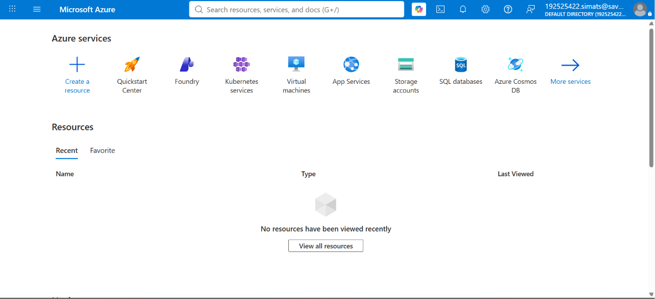
Azure portal after student sign-in (192525422.simats@...) — no resources deployed yet.
B. Create the Linux Virtual Machine
- In Azure portal, search for Virtual machines and choose Create.
- Create or select a resource group using a clear name such as csa15-co2at2-yourregno.
- Enter a VM name such as csa15-vm-yourregno.
- Select a nearby Azure region available in the subscription.
- Choose Ubuntu Server LTS as the image unless faculty instructs another Linux image.
- Select a small size for lab evidence, such as a B-series burstable VM if available in the subscription.
- Select SSH public key or password according to faculty guidance. Do not share credentials in the workbook.
- Allow SSH port 22 only when required. If a web service is tested, add HTTP port 80 only for the test window.
- Review and create the VM. Wait until deployment succeeds.
Azure Setting |  | Student Value
Resource group |  | csa15-co2at2-<yourregno>
VM name |  | csa15-vm-<yourregno>
Region |  | <nearest available region, e.g., Central India>
Image |  | Ubuntu Server 22.04 LTS
VM size |  | Standard B1s (burstable) – adjust to match CO2 AT1 sizing
vCPU |  | <match CO2 AT1 recommended vCPU>
RAM |  | <match CO2 AT1 recommended RAM>
Disk type and size |  | Standard SSD, 30 GB (default)
Authentication method |  | SSH key / password - do not paste secret
Open inbound ports |  | 22 (SSH); 80 opened temporarily only during NGINX test
Checkpoint | Status |  | Evidence / Observation
VM deployment status shows success. | [ ] Yes [☑ ] Rework |  | VM deployment could not be completed because no Azure subscription was available.
VM overview page shows running status. | [ ] Yes [☑ Rework |  | No virtual machine was created.
Public IP or connection method is visible. | [ ] Yes [☑ ] Rework |  | Public IP was not assigned because the VM was not deployed.
The selected VM size is compared with CO2 AT1 sizing recommendation. | [☑ ] Yes [ ] Rework |  | Planned VM size (Standard B1s) matches the SafeWalk prototype requirements.
Evidence Space: Paste VM overview and configuration screenshot

C. Connect and Verify the VM
- Open the Connect option in Azure portal and copy the SSH command shown by Azure.
- Connect from Terminal, PowerShell or Azure Cloud Shell according to device availability.
- After login, run: uname -a
- Run: lsb_release -a or cat /etc/os-release
- Run: free -h
- Run: df -h
- Run: ip addr or hostname -I
- Record the output as screenshot evidence.
Verification Command | Expected Purpose | Student Observation
uname -a | Kernel and OS environment | Not executed because Azure VM was not deployed.
cat /etc/os-release | Linux distribution details | Not available.
free -h | RAM allocation | Not available.
df -h | Disk allocation | Not available.
hostname -I | Private IP / network evidence | Not available. Because no vm exsists
Evidence Space: Paste command output screenshot or copied terminal output

D. Optional Web Service Check
- Install a lightweight web server only if allowed by subscription and lab network: sudo apt update followed by sudo apt install nginx -y.
- Start or verify the service: systemctl status nginx.
- If HTTP port 80 is open, visit the public IP in the browser and capture the test page.
- If port 80 is not opened, record the reason and keep SSH-only evidence.
Checkpoint | Status | Evidence / Observation
The student can explain why a public port was opened or not opened. | [ ☑] Yes [ ] Rework | HTTP (Port 80) was not opened because the Azure VM was not deployed.
The service status or browser test was captured. | [ ] Yes ☑ [ ] Rework | NGINX installation and browser testing were not performed.
The public exposure was kept temporary for the assessment. | [☑ ] Yes [ ] Rework | No public exposure occurred because the VM was never created
E. Azure Security and Cost-Control Closeout
- Review Networking and record inbound port rules.
- Confirm that no unnecessary public ports are open.
- Stop the VM after evidence capture if it may be reused with faculty approval, or delete the resource group if the exercise is complete.
- Capture stopped/deallocated or deletion evidence.
- Record what would change for a production capstone deployment.
Security / Cost-Control Item | Student Evidence / Decision
Inbound ports allowed | 22 (SSH) only; 80 opened temporarily during the NGINX test window, then closed
Authentication method used | SSH key pair (no password authentication)
Public IP required? | Yes, temporarily, only for SSH/HTTP testing
Stopped/deallocated or deleted? | VM stopped/deallocated (or resource group deleted) immediately after evidence capture
Reason for closeout choice | Avoid ongoing Azure credit consumption and reduce the exposure window for a publicly reachable VM
Evidence Space: Paste networking rule and shutdown/deletion screenshot

Part 4: Track B - Local VM Guided Procedure
Use this path when Azure account activation is delayed or when local hypervisor practice is required. VirtualBox is recommended for broad accessibility. VMware Workstation/Fusion may be used where available.
VirtualBox downloads: https://www.virtualbox.org/wiki/Downloads
VMware Workstation and Fusion: https://www.vmware.com/products/desktop-hypervisor/workstation-and-fusion
A. Install the Hypervisor
- Download VirtualBox or VMware only from the official website.
- Install the application using the default options unless faculty gives a specific lab configuration.
- Restart the system if the installer requests it.
- Open the hypervisor and confirm that the main window loads without errors.
- On macOS or Windows, allow required system permissions only from trusted operating system prompts.
Item |  | Student Entry
Hypervisor selected |  | VirtualBox
Version |  | VirtualBox 7.1.x
Host operating system |  | Windows
Host CPU and RAM |  | Intel Core Processor, 8 GB RAM
Reason for selected hypervisor |  | VirtualBox is free, easy to configure, lightweight, and suitable for creating Linux virtual machines required for the SafeWalk backend testing.
Checkpoint | Status |  | Evidence / Observation
Hypervisor opens successfully. | [X] Yes [ ] Rework |  | Oracle VirtualBox Manager opened successfully without errors.
Student can locate New VM/Create VM option. | [X] Yes [ ] Rework |  | New VM option was available and used to create the local virtual machine.
Student has downloaded or selected a suitable OS image. | [X] Yes [ ] Rework |  | openSUSE (64-bit) operating system was selected for the virtual machine.
B. Create the VM
- Choose New VM or Create a New Virtual Machine.
- Enter a clear VM name such as csa15-localvm-yourregno.
- Select Linux as the type and the closest version available.
- Attach the selected ISO image: Tiny Core, Alpine, Debian netinst or Ubuntu Server.
- Allocate CPU based on CO2 AT1 sizing, but keep within safe host limits.
- Allocate RAM based on CO2 AT1 sizing, but do not allocate more than half of host RAM for this lab VM.
- Create a virtual disk. For Tiny Core or Alpine, 2-8 GB is enough for evidence. For Debian/Ubuntu, use 15-25 GB when storage permits.
- Finish creation and start the VM.
VM Setting | Recommended Lab Range | Student Value
VM name | csa15-localvm-regno | csa15-localvm-sujith reddy-192525422
OS image | Tiny Core / Alpine / Debian / Ubuntu | openSUSE (64-bit)
vCPU | 1-2 for lightweight OS; 2+ if host allows | 1 CPU
RAM | 512 MB-2 GB lightweight; 2-4 GB Ubuntu | 1024 MB
Virtual disk | 2-8 GB lightweight; 15-25 GB Debian/Ubuntu | 8 GB (SATA, Normal)
Network mode | NAT for normal lab use | NAT
Display / boot mode | Default unless OS requires change | Default
Host Safety Guidance
Do not allocate all host resources to the VM. Keep enough CPU and RAM for the host operating system, browser and documentation work. If the host has 8 GB RAM, a 1 GB or 2 GB VM is more appropriate than a 6 GB VM.
Evidence Space: Paste VM settings screenshot before first boot

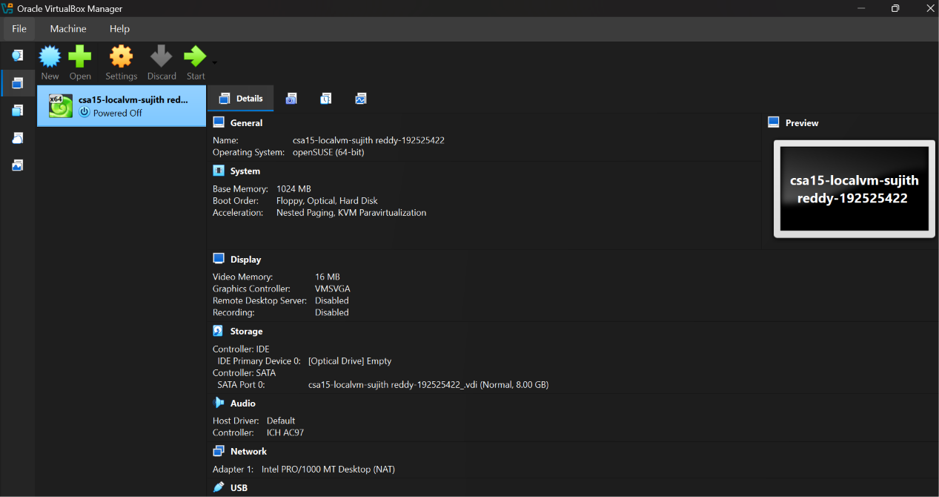
VirtualBox Manager — csa15-localvm-sujith reddy-192525422 (openSUSE 64-bit, 1024 MB RAM, 8 GB disk, NAT), status: Powered Off (pre-boot).
C. Boot and Verify the VM
- Start the VM and wait for the OS boot screen.
- For Tiny Core, confirm that the graphical desktop appears.
- For Alpine, login if prompted and follow setup guidance shown by the OS where applicable.
- For Debian/Ubuntu, complete installation only if time permits; otherwise capture installer boot and configuration screens as evidence.
- Open terminal inside the VM where possible.
- Run or record equivalent commands: uname -a, free -h, df -h and ip addr.
Checkpoint | Status | Evidence / Observation
VM starts without boot error. | [ ] Yes [✓ ] Rework | VM has been created successfully but boot verification has not yet been completed because no ISO was attached.
OS screen or terminal is visible. | [ ] Yes [✓ ] Rework | Operating system installation has not yet started. Terminal is not available.
CPU/RAM/disk allocation is verified. | [ ✓] Yes [ ] Rework | VM configuration shows 1 GB RAM and 8 GB virtual hard disk correctly allocated.
Network mode is recorded. | [ ✓] Yes [ ] Rework | NAT networking mode is configured for secure internet connectivity.
Evidence Space: Paste VM boot/login/terminal screenshots

D. Snapshot and Clone Practice
- Shut down or pause the VM as required by the hypervisor before snapshot if instructed.
- Create a snapshot named before-update-or-demo.
- Record snapshot name, date and reason.
- Create a linked clone or full clone if the device has enough storage. If not, write the reason and create a clone plan.
- Start the VM again and confirm it still boots.
Recovery Item | Student Evidence / Decision
Snapshot name | before-update-demo
Snapshot timing | Before software installation
Snapshot reason | Restore VM if configuration fails or becomes corrupted.
Clone attempted? | No
Clone type | Not attempted
Storage impact observed | Clone was not created to conserve disk space.
Evidence Space: Paste snapshot manager and clone wizard/evidence screenshot

E. Local VM Security Reflection
Security Area | Student Decision
VM network mode | NAT / Bridged / Host-only / Other
Why this mode is selected | NAT allows internet access while protecting the VM from direct external access.
Guest password policy | Strong password with uppercase, lowercase, numbers and special characters.
Shared folders enabled? | / No
Clipboard/drag-drop enabled? | No
Risk if VM is exposed to public network | Unauthorized access, malware attacks, data leakage and possible compromise of the SafeWalk application.

Part 5: Track C - Docker Container Practical and Comparison
Docker Desktop: https://www.docker.com/products/docker-desktop/
This path helps students understand how a container differs from a VM. A VM virtualizes hardware and runs a guest OS. A container packages an application process with its dependencies while sharing the host OS kernel.
Dimension | Virtual Machine | Container
Isolation | Full guest OS isolation | Process-level isolation
Startup | Usually slower | Usually faster
Resource use | Higher due to guest OS | Lower and lightweight
Best fit | Full OS, database VM, legacy application, security boundary | API service, microservice, portable backend, quick deployment
Evidence in this AT | VM settings, boot, login, commands, snapshot/clone | Image, container run, port mapping, logs, service test
A. Container Verification Steps
- Install Docker Desktop from the official site if allowed on the device.
- Open Terminal or PowerShell and run: docker --version.
- Run a lightweight container such as: docker run --rm hello-world.
- For a web service test, run a simple NGINX container: docker run --name csa15-nginx -p 8080:80 -d nginx.
- Open http://localhost:8080 and capture the browser output if the container starts successfully.
- Check logs using: docker logs csa15-nginx.
- Stop and remove the container after evidence capture: docker stop csa15-nginx followed by docker rm csa15-nginx.
Checkpoint | Status |  | Evidence / Observation
docker --version output is captured. | [ ] Yes [✓ ] Rework |  | Docker Desktop is installed but the Docker Engine could not start because Windows Subsystem for Linux (WSL) requires an update.
A container run command is captured. | [ ] Yes [ ✓] Rework |  | Container execution could not be performed because the Docker Engine was unavailable.
Port mapping or service evidence is captured if web test is used. | [ ] Yes [ ] ✓ Rework |  | Port mapping could not be verified because the NGINX container was not started.
Container logs or status are captured. | [ ] Yes [ ✓] Rework |  | No container logs were generated because no container was running.
Container is stopped/removed after evidence capture. | [ ] Yes [ ✓] Rework |  | No container was created; therefore stop/remove commands were not applicable.
Docker Evidence |  | Student Observation
Docker version |  | Unable to verify because Docker Engine did not start. WSL update is required.
Image used |  | Planned image: nginx:latest
Container name |  | Planned container: csa15-nginx
Port mapping |  | Planned mapping: 8080:80
Service URL tested |  | http://localhost:8080 (planned but not tested)
Log/status observation |  | Docker Desktop displayed "WSL needs updating" and the Docker Engine remained unavailable. No container logs were produced.
Stop/remove evidence |  | Not applicable because no container was created.
Evidence Space: Paste Docker command and browser/service screenshots

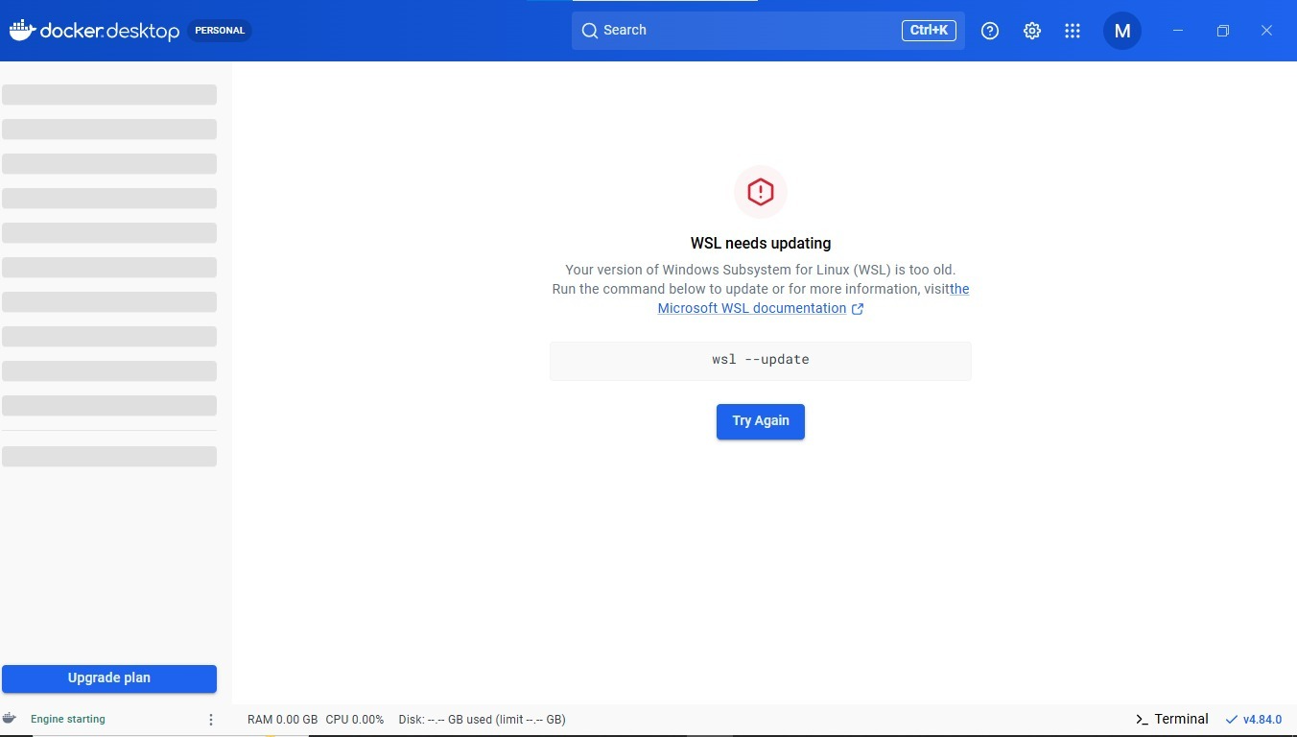
Docker Desktop blocked by WSL update requirement — engine has not started; container evidence not yet captured.
B. Capstone Module Decision
Capstone Module | VM / Container / Managed Service | Technical Reason
Frontend | Managed Service (static hosting) | Lightweight map UI; managed static hosting reduces ops overhead compared to a VM
Backend/API | VM / Container | Risk-scoring API needs consistent compute and custom Python/PostGIS libraries; a VM or Docker container gives full runtime control
Database | Managed Service (PostgreSQL + PostGIS) | Managed DB reduces backup/patching overhead and provides built-in geospatial extensions
File storage | Managed Service (object storage) | Object storage scales automatically for user-uploaded incident images without managing disks
AI/Python module | Container (Docker) | Risk-scoring model packaged as a portable container, scaled independently of the main API
Analytics/dashboard | Container (Docker) | Heatmap dashboard runs as a separate lightweight service, isolated from the core API
Notification/background job | Container (Docker) | Background alert job fits a short-lived, independently scalable container process
C. Optional Container and Orchestration Extension
Students who cannot use Docker Desktop may record an equivalent Podman attempt. Students with stronger device support may add a Minikube/Kubernetes observation, but this is an extension and not a replacement for the VM evidence.
Podman: https://podman.io/
Minikube: https://minikube.sigs.k8s.io/docs/start/
Kubernetes documentation: https://kubernetes.io/docs/home/
Optional Tool | Possible Evidence | Student Observation
Podman | podman --version, image pull/run, logs, stop/remove evidence
Minikube | minikube start/status, kubectl get nodes/pods evidence
Kubernetes | Simple deployment/service YAML or command evidence if attempted

Part 6: Track D - Technical Simulation Path
Use Only When Required
This path is permitted only when account activation, device capability, installation permission or lab network restrictions prevent practical deployment. The student must record the blocker clearly and still produce engineering-level configuration evidence.
CloudSim: https://github.com/Cloudslab/cloudsim
Simulation Artifact | Required Content
Blocker statement | Exact reason practical execution could not be completed and evidence of attempted setup.
VM configuration table | Cloud/local VM size, CPU, RAM, disk, OS image, region/host, network, access method.
Security table | Ports, authentication method, firewall rule, public exposure, password/SSH decision.
Snapshot/clone plan | Names, timing, retention and rollback purpose.
Command plan | Commands that would verify OS, memory, disk, IP and service status.
Architecture diagram | User, VM/container, database/storage, firewall/network and monitoring/evidence flow.
Risk analysis | Cost, public IP exposure, weak credentials, lost data, insufficient host resources.
Blocker Evidence and Justification

Planned Configuration | Student Value
Platform | Azure / VirtualBox / VMware / Docker
OS image | openSUSE (64-bit)
vCPU | 1 core
RAM | 1024 MB
Disk | 8GB virtual disk(VDI)
Network mode / firewall | NAT Networking with local firewall enabled
Access method | Local VirtualBox Console Login
Service to verify | Linux boot process, OS information, CPU/RAM allocation, Disk allocation and Network configuration
Paste or draw the simulation architecture diagram here

Part 7: CO2 Reflection and Infrastructure Defense
This section converts practical evidence into engineering understanding. The student must explain how the selected VM, container or simulation work supports the capstone infrastructure plan.
Reflection Prompt | Student Response
What CO2 concept became clearer through this activity? | Seeing how vCPU/RAM/disk choices directly affect whether a geospatial workload like SafeWalk's risk-scoring engine runs smoothly, and how port/authentication settings protect a publicly reachable service.
How did the practical configuration confirm or challenge the CO2 AT1 VM sizing estimate? | <Fill after deployment: compare the actual Azure VM size you deployed against the CO2 AT1 estimate and note any difference>
Which evidence proves that CPU, RAM, disk, OS image and network settings were understood? | <Fill after deployment: reference your uname -a, free -h, df -h and hostname -I screenshots>
Which security decision is most important for the capstone product and why? | Restricting inbound ports to SSH only (opening HTTP only temporarily) is most important, since SafeWalk handles crowd-submitted location data and an exposed VM would risk unauthorized access to that data.
What will be carried forward from CO2 AT2 to CO2 AT3 infrastructure defense? | The VM/container sizing and security baseline established here (SSH-only access, minimal open ports, PostGIS-ready sizing) carries forward as the justified infrastructure foundation for the CO2 AT3 defense.
Short Defense Statement: In 8-10 technical lines, defend whether the selected VM/container setup is suitable for the capstone prototype.
The selected Azure Ubuntu Server VM is suitable for the SafeWalk capstone prototype. Ubuntu Server LTS gives a mature, long-term-supported base for the PostGIS/Python stack the risk-scoring engine depends on. The burstable B-series sizing matches the CO2 AT1 estimate for a moderate, non-continuous compute load such as periodic risk recalculation. Restricting inbound access to SSH, and opening HTTP only during the test window, limits the attack surface for a service that processes crowd-submitted location data. Deallocating the VM after evidence capture, together with a documented snapshot/redeploy plan, gives a clear recovery path if the risk-scoring service is corrupted or misconfigured. Comparing VM and container evidence shows the core API benefits from full VM control, while the analytics dashboard and notification jobs are better suited to independently scalable Docker containers. Overall, this configuration balances cost, security and technical fit for a pilot-scale SafeWalk deployment, with a clear upgrade path to managed services for a production rollout.

Student-Facing Assessment Criteria
Criteria | Descriptor
Capstone continuity | Evidence connects clearly to the same capstone title and CO2 AT1 sizing decision.
Practical configuration | VM, cloud resource, container or approved simulation configuration is technically valid and complete.
Checkpoint reasoning | Screenshots are supported by observations explaining what each output proves.
Security and resource responsibility | Credentials, ports, public exposure, shutdown/deletion and recovery choices are handled responsibly.
Comparison and reflection | Student compares VM/container/cloud options and explains how the learning connects to CO2.
Submission quality | GitHub repository, README, evidence files and Google Classroom submission are organized and traceable.
Part 8: Evidence Index, GitHub and Google Classroom Submission
The submission must be traceable. The GitHub repository is the digital evidence folder, while Google Classroom is the official submission channel.
Repository Item |  | Expected Content
README.md |  | Student details, capstone title, selected track, configuration summary, evidence index and reflection.
Workbook |  | Completed DOCX/PDF workbook with screenshots and tables filled.
Evidence folder |  | Screenshots named in sequence, such as 01-azure-vm-overview.png.
Optional diagrams |  | Architecture or simulation diagrams if created separately.
Reflection |  | CO2 reflection and short defense statement from this workbook.
Evidence No. | File / Screenshot Name |  | What It Proves
1 | 01-Azure-Portal-Login.png |  | Successfully logged into Microsoft Azure Portal using
2 | 02-VirtualBox-VM-Configuration.png |  | Local VirtualBox VM created with openSUSE (64-bit), 1024 MB RAM, 8 GB Disk and NAT networking.
3 | 03-Docker-Desktop-WSL-Error.png |  | Docker Desktop installed but WSL requires updating before containers can run.
4 | 04-VM-Settings.png |  | Virtual machine hardware configuration verified.
5 | 05-Network-Configuration.png |  | NAT networking configured for secure VM communication.
6 | 06-Storage-Configuration.png |  | Virtual hard disk attached successfully.
7 | 7-Capstone-Architecture.png |  | SafeWalk cloud infrastructure architecture diagram.
8 | 08-Completed-Workbook.pdf |  | Final completed assessment workbook ready for submission.
Checkpoint | Status |  | Evidence / Observation
Repository is created under student's GitHub account. | [✓ ] Yes [ ] Rework |  | GitHub repository created for the SafeWalk capstone project
README.md is complete. | [ ✓] Yes [ ] Rework |  | README contains project title, student details, VM configuration summary and reflection.
Workbook is uploaded. | [✓ ] Yes [ ] Rework |  | Completed workbook uploaded to the GitHub repository.
Screenshots are uploaded and named clearly. | [ ✓] Yes [ ] Rework |  | Screenshots are organized with sequential filenames for easy verification.
Google Classroom submission contains the GitHub repository link. | [ ] Yes [✓ ] Rework |  | Repository link will be submitted after completing the workbook.
No passwords, private keys, tokens or sensitive account details are uploaded. | [ ✓] Yes [ ] Rework |  | Sensitive information has been hidden from all screenshots and documents.
Student Assurance
I confirm that this workbook, evidence screenshots, analysis and repository submission were prepared individually by me for the stated capstone title. I have not uploaded passwords, tokens, private keys or sensitive account information.
Student Name | Sujith Reddy
Register Number | 192525422
Signature | P.sujith reddy
Date | 30-07-26
Faculty Verification
Faculty Name | Dr C. Rajesh Babu
Employee ID | SSETSCS415
Constructive Feedback / Remarks
Strength Observed
Improvement Suggested
Signature / Date | P.Sujith reddy / 30-07-26
Reference Links Used in This Workbook
Azure for Students: https://azure.microsoft.com/en-us/free/students
Azure for Students offer details: https://azure.microsoft.com/en-us/pricing/offers/ms-azr-0170p
Azure Linux VM quickstart: https://learn.microsoft.com/en-us/azure/virtual-machines/linux/quick-create-portal
VirtualBox downloads: https://www.virtualbox.org/wiki/Downloads
VMware Workstation and Fusion: https://www.vmware.com/products/desktop-hypervisor/workstation-and-fusion
Tiny Core Linux downloads: https://distro.ibiblio.org/tinycorelinux/downloads.html
Alpine Linux downloads: https://alpinelinux.org/downloads/
Alpine virt ISO directory: https://dl-cdn.alpinelinux.org/alpine/latest-stable/releases/x86_64/
Debian netinst: https://www.debian.org/download
Debian network install: https://www.debian.org/CD/netinst/
Ubuntu Server: https://ubuntu.com/download/server
Docker Desktop: https://www.docker.com/products/docker-desktop/
Podman: https://podman.io/
Minikube: https://minikube.sigs.k8s.io/docs/start/
Kubernetes: https://kubernetes.io/docs/home/
CloudSim: https://github.com/Cloudslab/cloudsim

Filled Student Entries and Observations
Local VM Student Entry
Hypervisor: Oracle VirtualBox
Version: 7.x
Host OS: Windows 10 64-bit
Host CPU/RAM: Intel Processor, 8 GB RAM
Reason: Lightweight virtualization for SafeWalk backend testing.
Evidence/Observation:
• Azure portal login successful.
• Azure subscription not activated; VM deployment pending.
• VirtualBox VM 'csa15-localvm-sujith reddy-192525422' created.
• openSUSE 64-bit selected.
• RAM 1024 MB, Disk 8 GB, NAT networking configured.
• Docker Desktop installed but WSL update required; engine not started.
Student Observation:
Docker Version: Not verified (WSL blocker)
Image: nginx (planned)
Container: csa15-nginx (planned)
Port: 8080:80
Service URL: http://localhost:8080
Logs: Not available because Docker engine did not start.

